**Testing SOAP and REST API Request using SoapUI Open Source version 5.4.0**

**Tools and Technology used for the above testing are:**

* SoapUI Open Source version 5.4.0
* Language used for scripting Groovy
* Git version 2.16.1 for Windows
* GitHub Repository path <https://github.com/SanjayAdav1972/SoapUIProject>
* Jenkins war file

**Steps to view the code and document:**

1. Clone the GitHub repository <https://github.com/SanjayAdav1972/SoapUIProject.git>
2. Install and SoapUI open source
3. Import REST-Project-1-soapui-project.xml and CountryInfoService-soapui-project.xml
4. Run the request through SoapUI, Command line or through Jenkins as shown below in this document
5. Kindly provide feedback or any more improvement required to my email id [sanjay.adav@gmail.com](mailto:sanjay.adav@gmail.com)

**The above project contains:**

1. How to add and retrieve properties in Project, Test Suite, Test Case and Test Step level
2. How to add and retrieve properties in System, Environment and Global level
3. How to add, Set, Update and Remove properties using Groovy scripting
   1. Kindly refer project CountryInfoService >> TestSuite2 >> CountryInfoServiceSoapBinding TestSuite >> Test Steps >> Groovy Script and
   2. Kindly refer project CountryInfoService >> TestSuite2 >> CountryInfoServiceSoapBinding TestSuite >> Test Steps >> GetSetProperties
4. How to transfer values from 1 API request to another API request
   1. Kindly refer project CountryInfoService >> Property

Here CountryISOCodeResult response of CountryISOCode request send as request to CapitalCity request

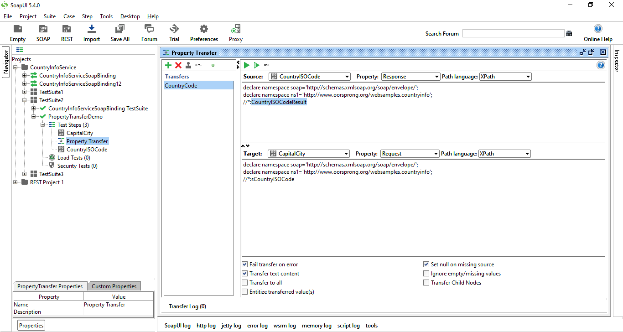

1. How to run any Request from GUI, Command line and Groovy script
2. How to run any Test Case from GUI, Command line and Groovy script
3. How to run any Test Suit from GUI, Command line and Groovy script
4. How to run any Project from GUI, Command line and Groovy script

Note: Kindly refer CountryInfoService >> TestSuite3 and all test cases inside will having respective Groovy scripts

1. How to troubleshoot SoaupUI project for any errors (View different types of logs)
2. Setup and TearDown groovy script
   1. Kindly refer REST Project 1 >> TestSuite2 >> Aruba TestCase >> SetupAndTeardownGroovy
3. Add various types of Assertions to validate the entity inside the response in GUI as well as using Groovy scripts

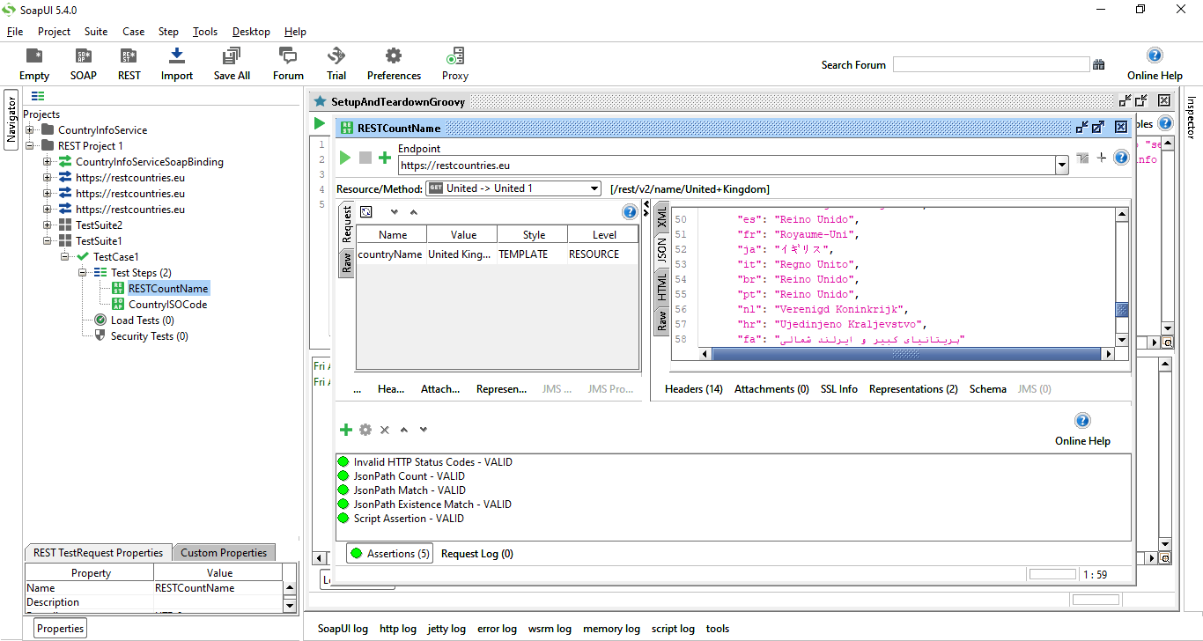

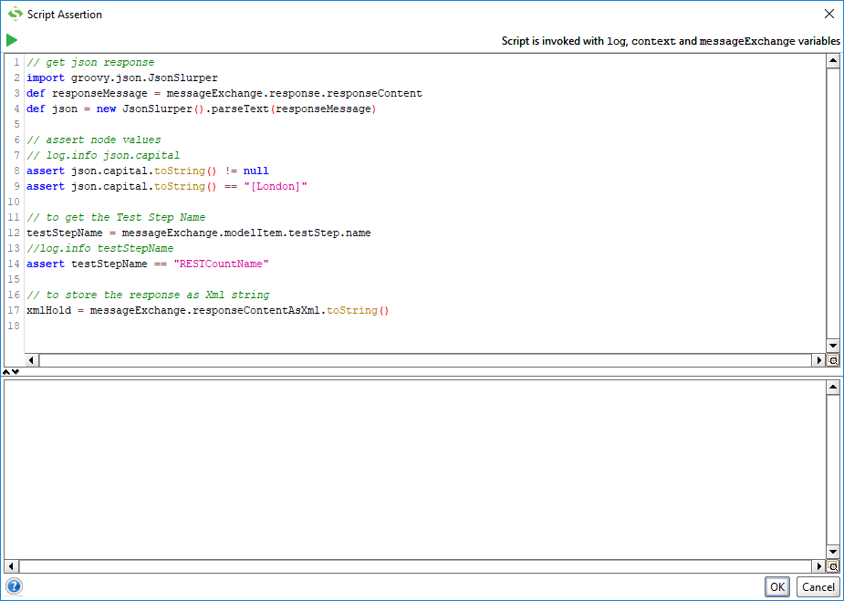

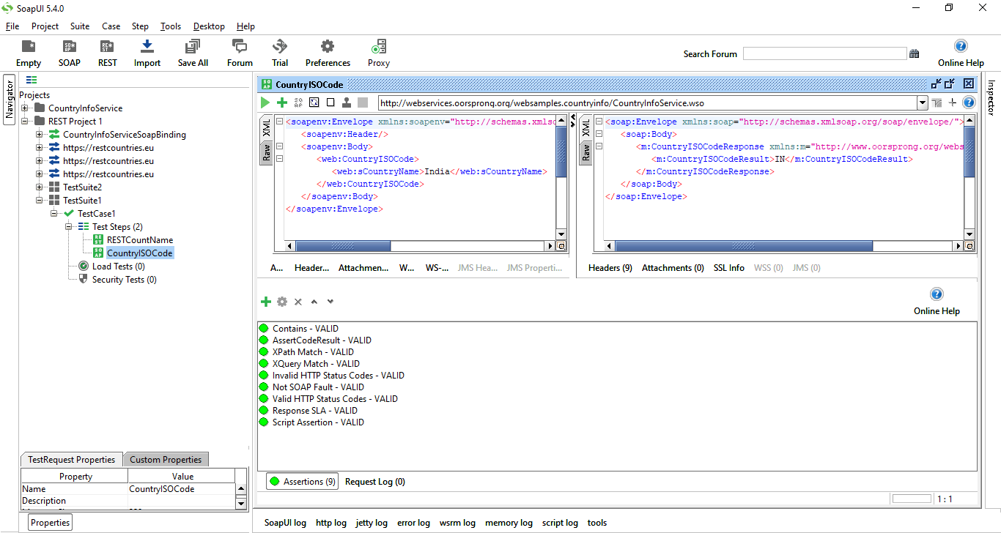

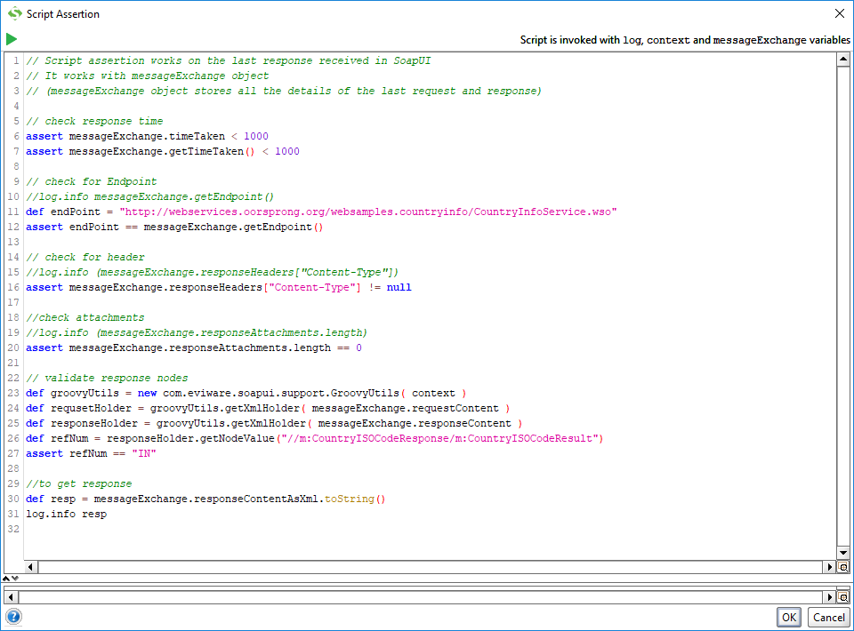

1. How to run SOAPUI test from Command line

Step 1 : Open SoapUI and go to the test case   
Step 2 : Right click and select Launch Test Runner   
Step 3 : Run from Test Runner and copy the commands

cd C:\Program Files\SmartBear\SoapUI-5.4.0\bin\  
testrunner.bat -sTestSuite1 -cTestCase1 "D:\Tutorials\SoapUI\Raghav Pal\REST-Project-1-soapui-project.xml"

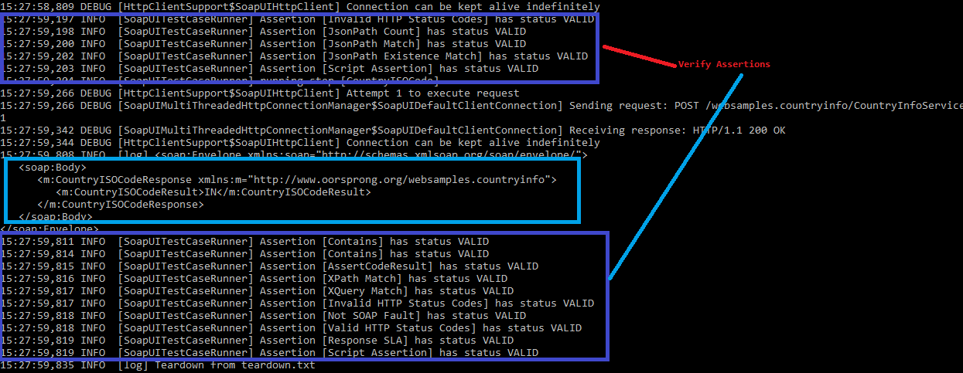

1. How to run SOAPUI test from Jenkins

Steps:

Step 4: Get Jenkins on your system (Download and Install)  
Step 5: Run jenkins - java -jar jenkins.war --httpPort=xxxx

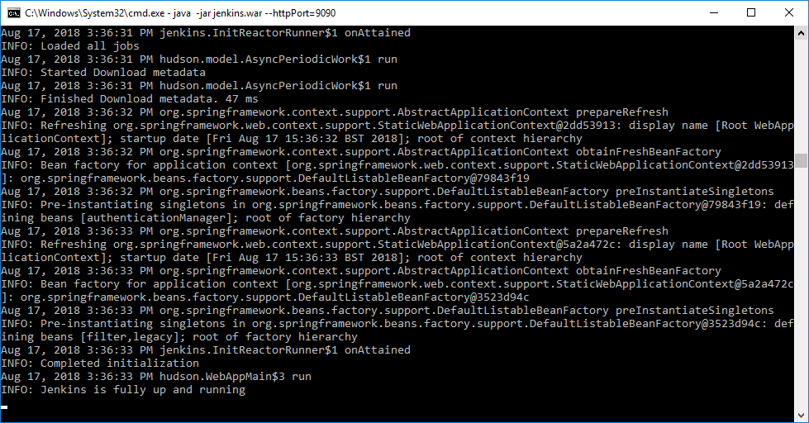

Step 6: Create a new job and add details

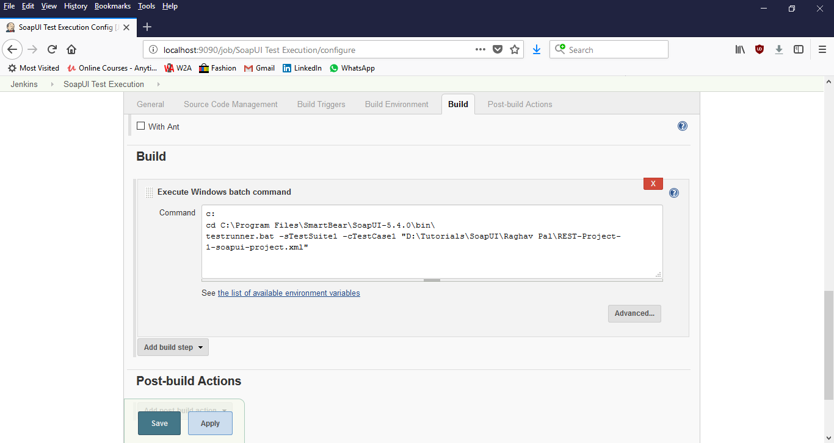

Step 7: Run the job and validate results

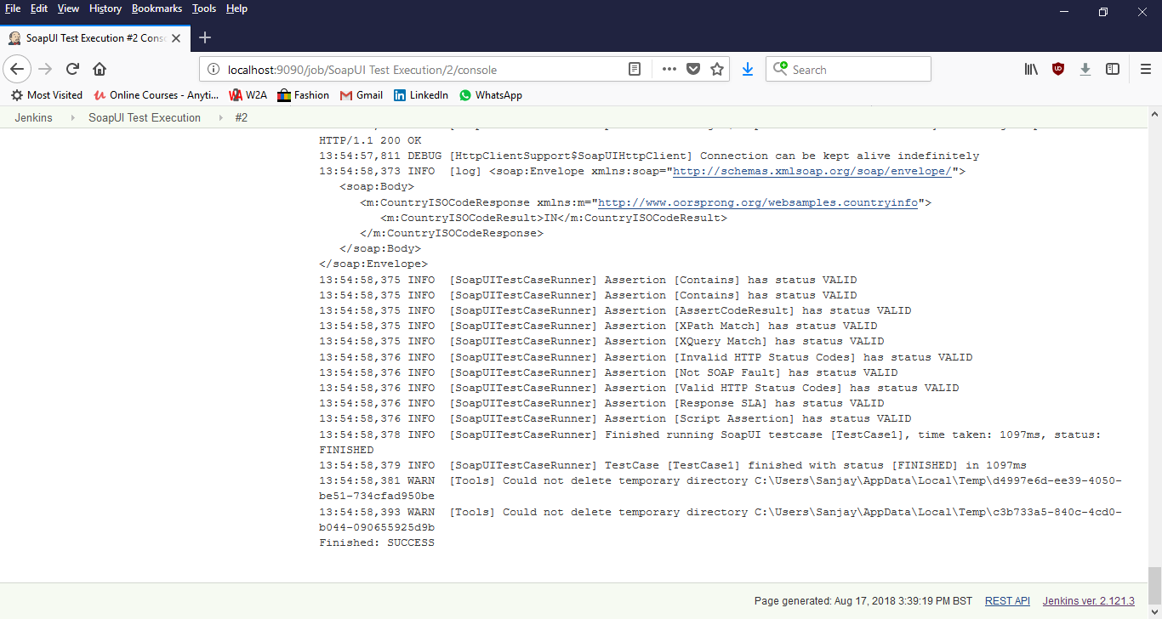

1. View the complete above SOAPUI code in GitHub

<https://github.com/SanjayAdav1972/SoapUIProject>

Kindly refer [Testing SOAP and REST API Request using SoapUI.docx](https://github.com/SanjayAdav1972/SoapUIProject/blob/master/Testing%20SOAP%20and%20REST%20API%20Request%20using%20SoapUI.docx) for more details